NAME: RAJDEEP SARKAR
ROLL:UG/02/BTCSECSF/2023/008
UDB LAB ASSIGNMENT 4
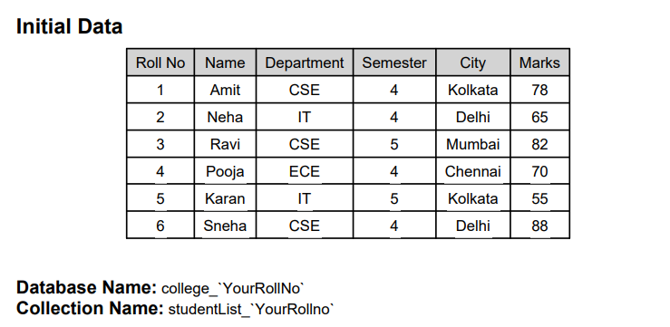

1.Display all student records using aggregation.
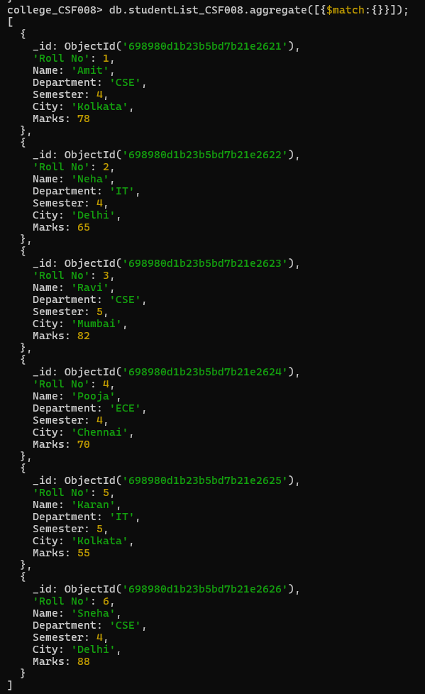
2. Display students belonging to CSE department
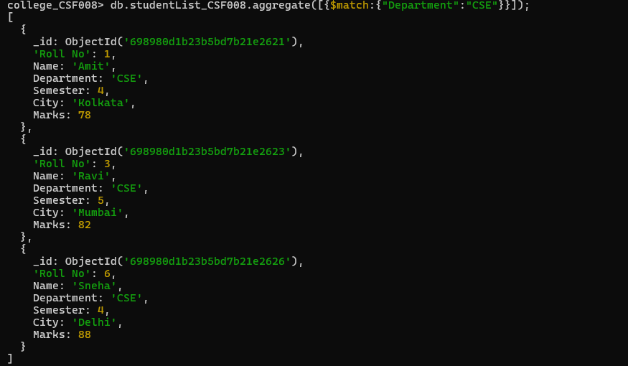
3. Display students of semester 4
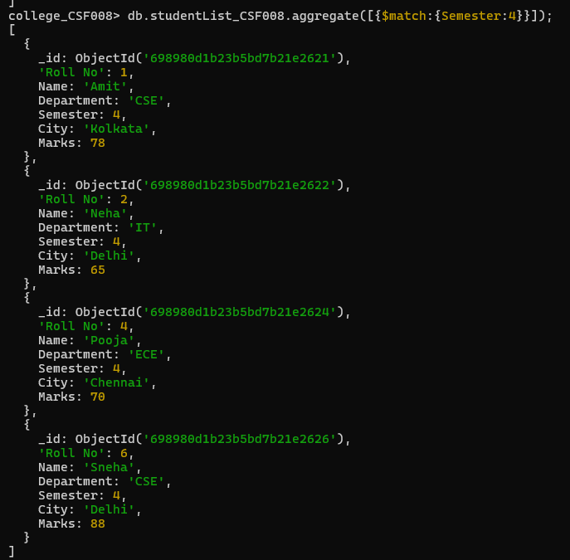

4. Display only name and marks of all students
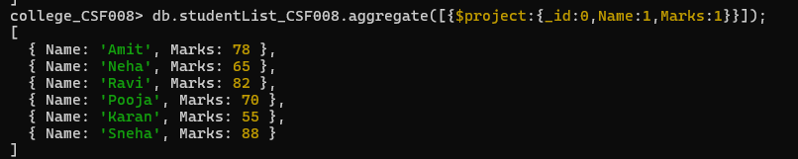
5. Find the average marks of all students
6. Find total marks scored department-wise
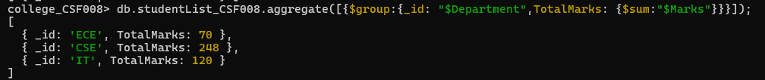
7. Find average marks department-wise
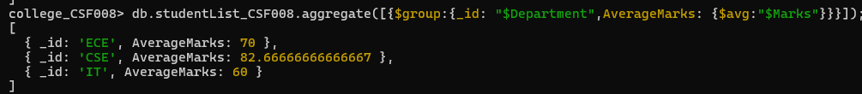
8. Find maximum marks scored in each department
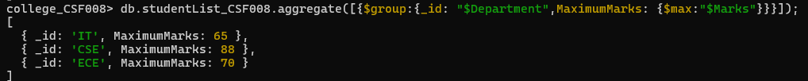
9. Count number of students in each department
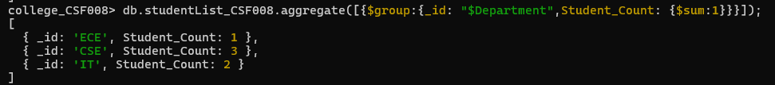
10. Display departments having average marks greater than 70
11. Sort students by marks in descending order
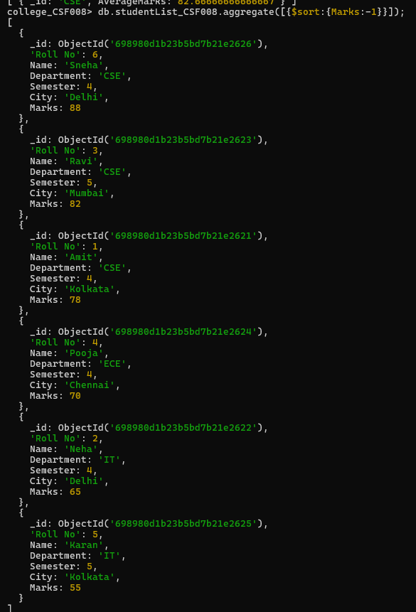
12. Display top 3 students based on marks
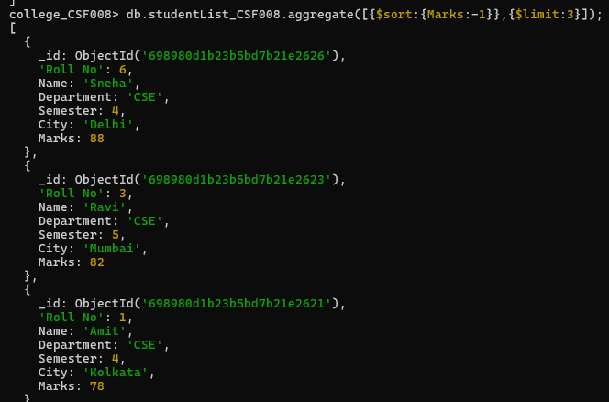
13. Display department-wise average marks sorted in descending order
14. Display students belonging to Delhi or Kolkata.
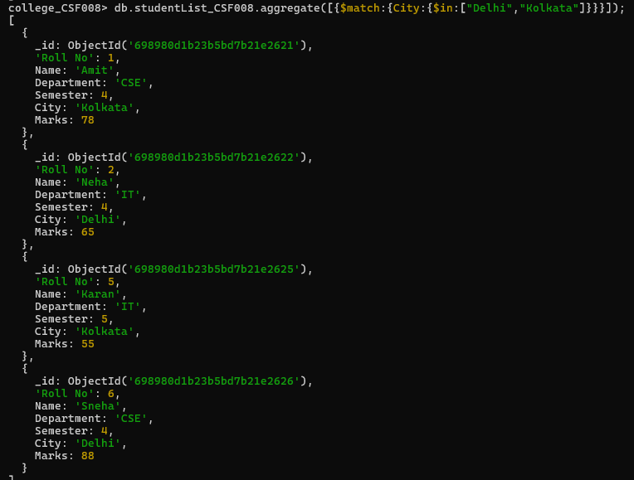

COMPASS SCREENSHOT:
